Week 4 Homework:
Arrays and Collections:
By Lauren Geislinger
09/19/2020

My first step was to write the code as depicted in the exercise.
I wanted to test and see if I could load the file as a CSV instead of a txt file, so splitting the data would be easier.
It printed my data to the screen, including the X names to be excluded in step 4.

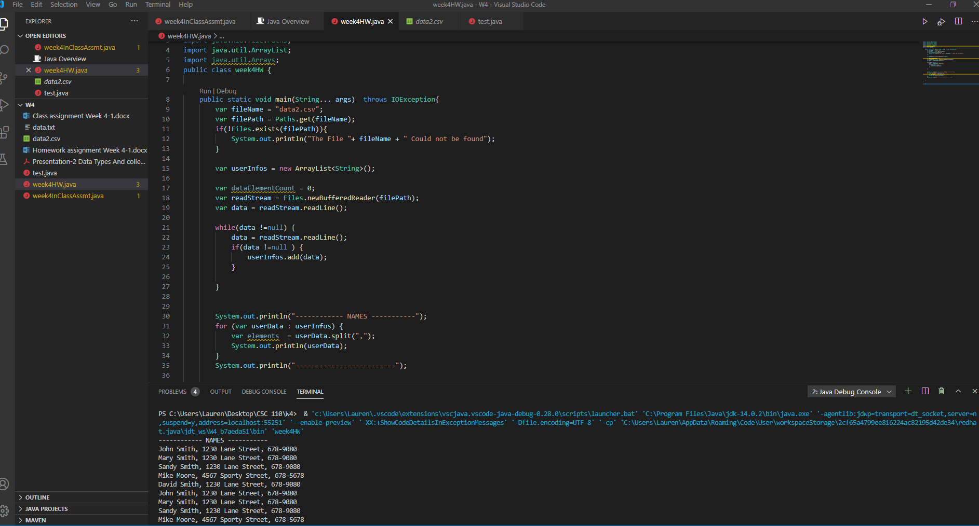

I wanted to separate my data by name, address and phone. My first though was to create tokens for each element and have a function that calls the tokens but after doing research I couldn’t get it to work.
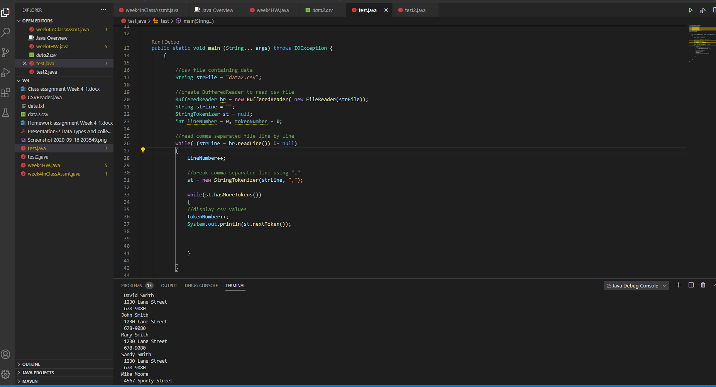

I think if worked more on this method it would have eventually worked, and I feel like I was on the right track, but decided later it was too tedious and would take more work, so I opted to instead just find a way to separate each element of the line into an array using .split(“ , “) and just using 3 different arrays. I also changed back to a txt file.

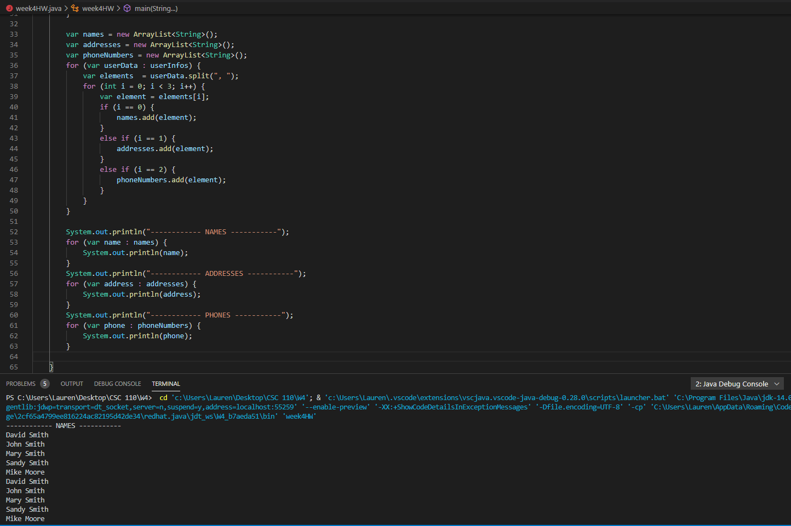

I created 3 separate arrays for names, addresses and phones, and created if and else if statements to separate the data based on where it was in the text file. When the for loop runs, it will note that elements at position 0 of the string, and add the element to the names arraylist. The else if statement for addresses adds position 1 to the addresses array, and the else if statement for phones adds elements in positions 2. The for loop keeps incrementing and stops at i< 3, because there are only 3 elements in each string.

For step 4, I did something similar with a for loop and if statement. I had had to research how to find the first value in a string. I found this article helpful. https://www.w3schools.com/java/java_ref_string.asp

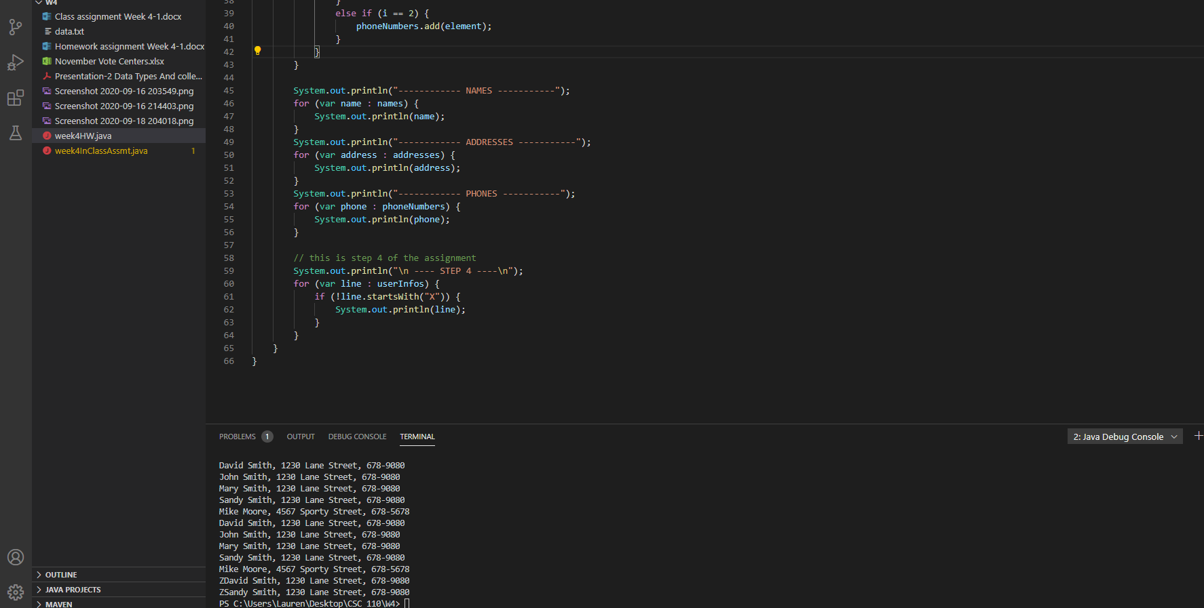
.startswith returns a boolean value, so I just had it set to not return anything in variable line that starts with an X.

